Regular Rectilinear Shapes
# Source: AI Source: Provided by: [Data Path: Persons Table -> ID Column: 1, Name_En Column: Motasem Essam] -> From: [ChatGPT] on [7/25/2026]
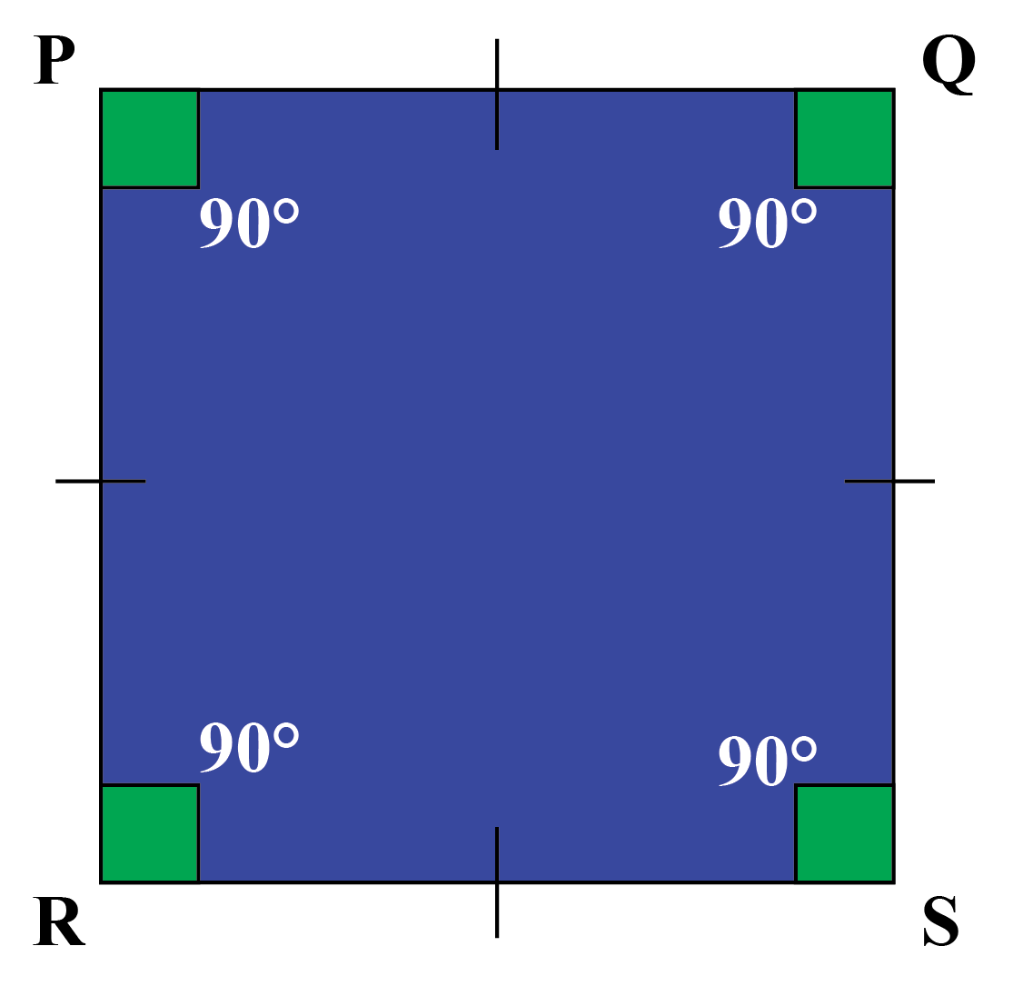
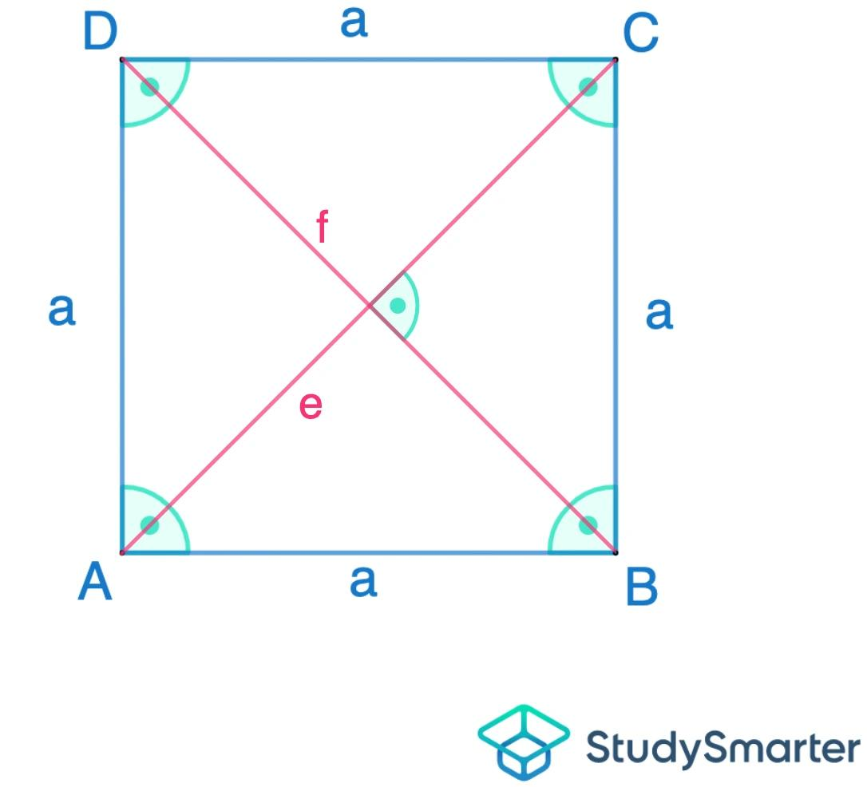
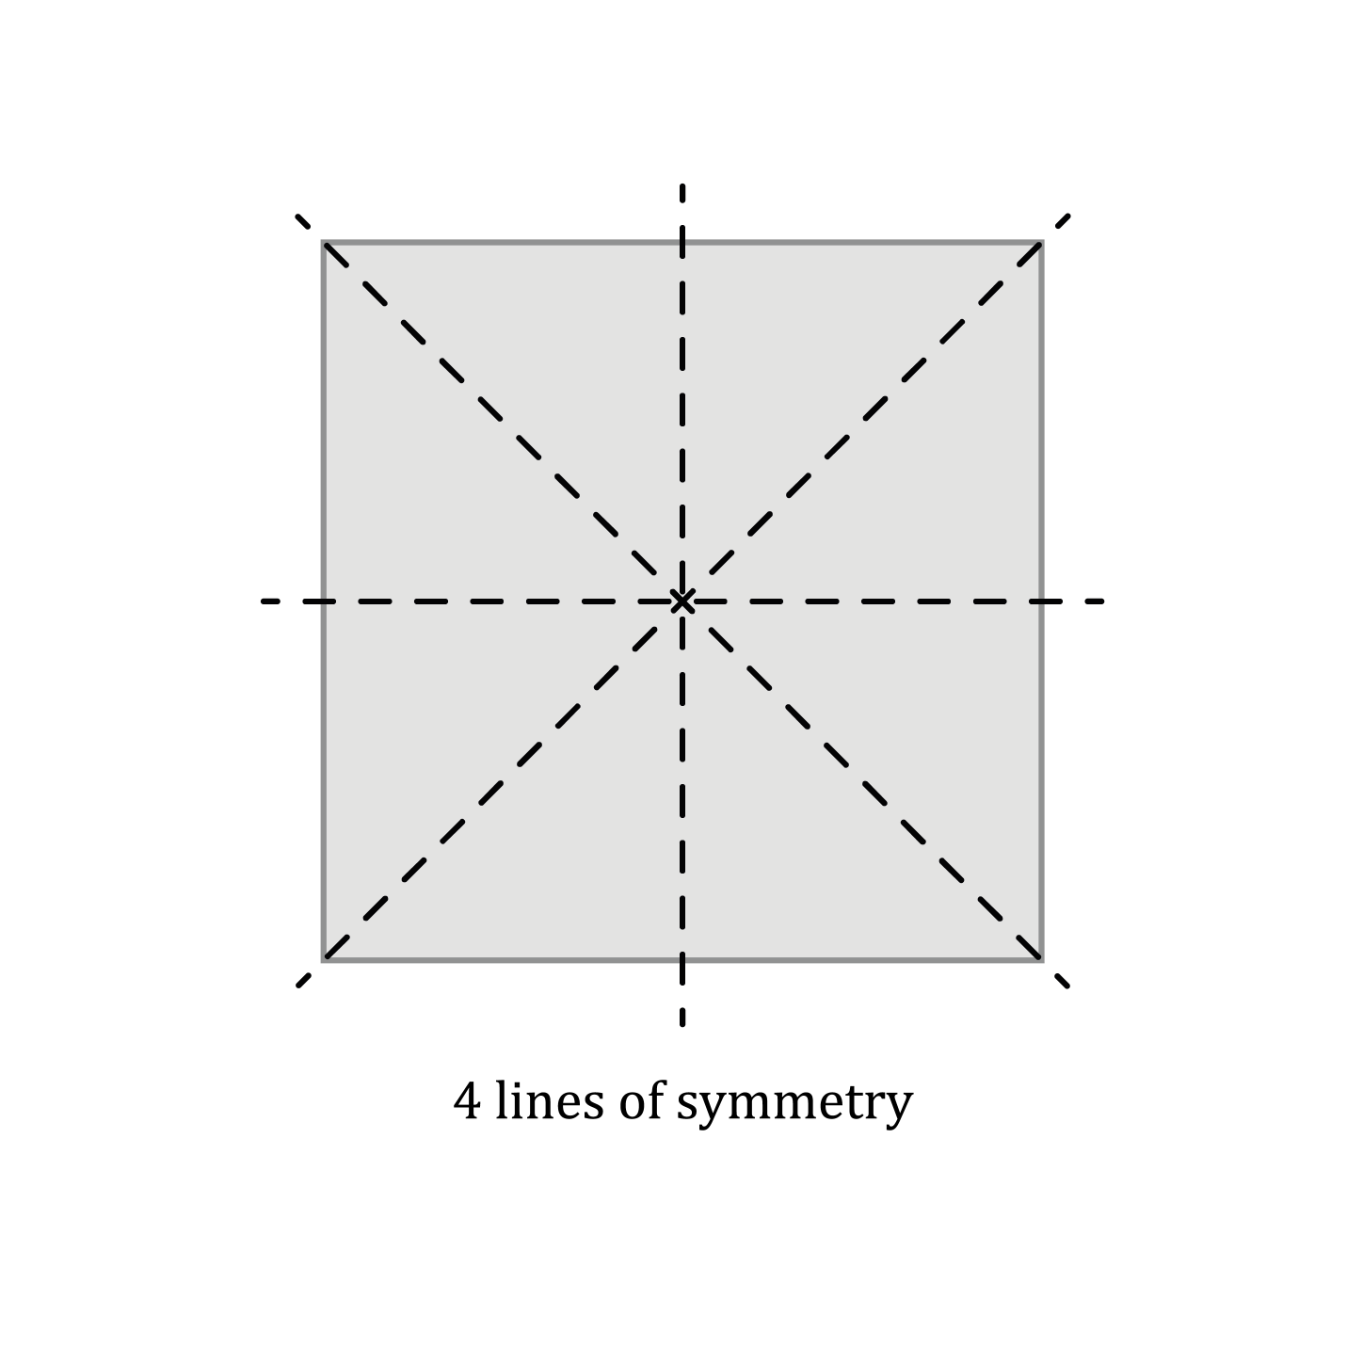

Definition
# Source: AI Source: Provided by: [Data Path: Persons Table -> ID Column: 1, Name_En Column: Motasem Essam] -> From: [ChatGPT] on [7/25/2026]
A Regular Rectilinear Shape is a rectilinear polygon in which the sides are equal in length and the angles are equal in measure.
A rectilinear polygon has only horizontal and vertical sides, with adjacent sides meeting at right angles. For a polygon to also be regular, all of its sides and all of its interior angles must be equal.
Therefore:
$$\boxed{\text{Regular Rectilinear Shape}=\text{Rectilinear Shape + Regular Polygon}}$$
In the standard mathematical sense, the square is the only regular rectilinear polygon.

Fundamental Concept
# Source: AI Source: Provided by: [Data Path: Persons Table -> ID Column: 1, Name_En Column: Motasem Essam] -> From: [ChatGPT] on [7/25/2026]
A regular polygon satisfies:
$$\text{All sides are congruent}$$
and
$$\text{All interior angles are congruent}$$
A rectilinear polygon has sides arranged only horizontally and vertically.
Combining these two conditions forces the polygon to have four sides:
$$\boxed{\text{Regular Rectilinear Polygon}=\text{Square}}$$
A square has:
- 4 equal sides
- 4 equal angles
- each interior angle ${90}^{∘}$
- horizontal and vertical sides

Main Characteristics
# Source: AI Source: Provided by: [Data Path: Persons Table -> ID Column: 1, Name_En Column: Motasem Essam] -> From: [ChatGPT] on [7/25/2026]
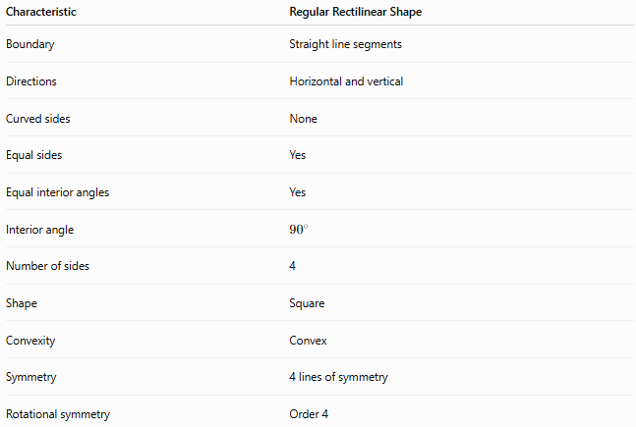
Characteristic | Regular Rectilinear Shape
Boundary | Straight line segments
Directions | Horizontal and vertical
Curved sides | None
Equal sides | Yes
Equal interior angles | Yes
Interior angle | $${90}^{∘}$$
Number of sides | 4
Shape | Square
Convexity | Convex
Symmetry | 4 lines of symmetry
Rotational symmetry | Order 4

The Square as the Regular Rectilinear Shape
# Source: AI Source: Provided by: [Data Path: Persons Table -> ID Column: 1, Name_En Column: Motasem Essam] -> From: [ChatGPT] on [7/25/2026]
The square is the fundamental example.
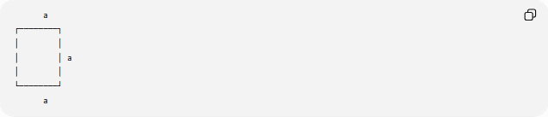
a
┌────────┐
│ │
│ │ a
│ │
└────────┘
a
For a square with side length $a$:
Side lengths
$$AB=BC=CD=DA=a$$
Angles
$$∠A=∠B=∠C=∠D={90}^{∘}$$
Perimeter
$$\boxed{P=4a}$$
Area
$$\boxed{A=a^{2}}$$
Diagonal
$$\boxed{d=a\sqrt{2}}$$

Why There Is Only One Regular Rectilinear Polygon
# Source: AI Source: Provided by: [Data Path: Persons Table -> ID Column: 1, Name_En Column: Motasem Essam] -> From: [ChatGPT] on [7/25/2026]
For a regular polygon with $n$sides, each interior angle is:
$$\frac{\left(n-2\right){180}^{∘}}{n}$$
For a rectilinear polygon, the sides are horizontal and vertical, so every interior angle must be:
$${90}^{∘}$$
Set the regular-polygon angle equal to ${90}^{∘}$:
$$\frac{\left(n-2\right){180}^{∘}}{n}={90}^{∘}$$
Multiply by $n$:
$$180\left(n-2\right)=90n \\ 180n-360=90n \\ 90n=360 \\ \boxed{n=4}$$
Thus, a regular rectilinear polygon must have four sides. A four-sided regular polygon is a square.

Classification
# Source: AI Source: Provided by: [Data Path: Persons Table -> ID Column: 1, Name_En Column: Motasem Essam] -> From: [ChatGPT] on [7/25/2026]
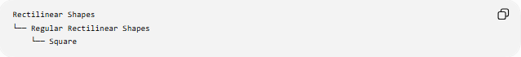
Rectilinear Shapes
└── Regular Rectilinear Shapes
└── Square
Unlike some descriptive shape classifications, there are no regular rectilinear pentagons, hexagons, octagons, or higher-sided regular polygons.
For example:
- Regular triangle → not rectilinear
- Regular pentagon → not rectilinear
- Regular hexagon → not rectilinear
- Regular octagon → not rectilinear
- Square → regular and rectilinear

Regular vs. Irregular Rectilinear Shapes
# Source: AI Source: Provided by: [Data Path: Persons Table -> ID Column: 1, Name_En Column: Motasem Essam] -> From: [ChatGPT] on [7/25/2026]
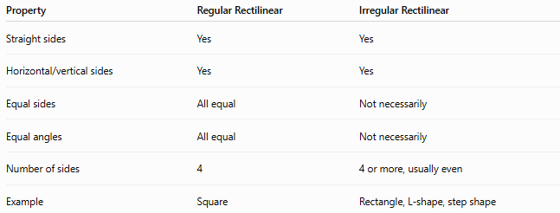
Property | Regular Rectilinear | Irregular Rectilinear
Straight sides | Yes | Yes
Horizontal/vertical sides | Yes | Yes
Equal sides | All equal | Not necessarily
Equal angles | All equal | Not necessarily
Number of sides | 4 | 4 or more, usually even
Example | Square | Rectangle, L-shape, step shape
An important distinction is that not every rectilinear shape with equal-looking directions is regular.
For example, a rectangle has:
$$AB=CD, BC=AD$$
but generally:
$$AB≠BC$$
so a non-square rectangle is not regular.

Square vs. Rectangle
# Source: AI Source: Provided by: [Data Path: Persons Table -> ID Column: 1, Name_En Column: Motasem Essam] -> From: [ChatGPT] on [7/25/2026]
A square is a special type of rectangle.
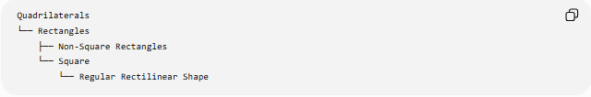
Quadrilaterals
└── Rectangles
├── Non-Square Rectangles
└── Square
└── Regular Rectilinear Shape
Every square is:
- a rectangle
- a rhombus
- a parallelogram
- a regular polygon
- a rectilinear polygon
But a general rectangle is not necessarily a regular polygon.

Symmetry
# Source: AI Source: Provided by: [Data Path: Persons Table -> ID Column: 1, Name_En Column: Motasem Essam] -> From: [ChatGPT] on [7/25/2026]
Because the square is regular, it has several symmetry properties.
Reflection Symmetry
A square has:
$$\boxed{4}$$
lines of symmetry:
- 2 through opposite side midpoints
- 2 along the diagonals
Rotational Symmetry
A square maps onto itself after rotations of:
$${90}^{∘}, {180}^{∘}, {270}^{∘}, {360}^{∘}$$
Therefore its rotational symmetry has order:
$$\boxed{4}$$
Point Symmetry
A square also has point symmetry because a ${180}^{∘}$rotation maps it onto itself.

Regular Rectilinear Shape vs. Square
# Source: AI Source: Provided by: [Data Path: Persons Table -> ID Column: 1, Name_En Column: Motasem Essam] -> From: [ChatGPT] on [7/25/2026]
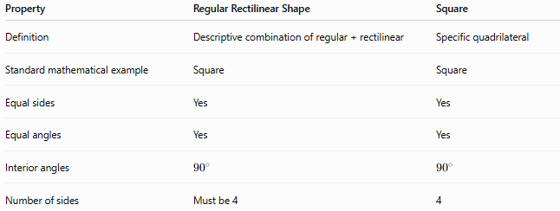
Property | Regular Rectilinear Shape | Square
Definition | Descriptive combination of regular + rectilinear | Specific quadrilateral
Standard mathematical example | Square | Square
Equal sides | Yes | Yes
Equal angles | Yes | Yes
Interior angles | $${90}^{∘}$$ | $${90}^{∘}$$
Number of sides | Must be 4 | 4
Thus:
$$\boxed{\text{Regular Rectilinear Shape}=\text{Square}}$$
when rectilinear shape is being used in its standard polygonal mathematical sense.

Important Terminology Note
# Source: AI Source: Provided by: [Data Path: Persons Table -> ID Column: 1, Name_En Column: Motasem Essam] -> From: [ChatGPT] on [7/25/2026]
“Regular rectilinear shape” is not generally treated as a separate standard polygon class in the same way as square, pentagon, or hexagon.
It is better understood as a descriptive category formed by combining:
- regular — equal sides and equal angles
- rectilinear — straight horizontal/vertical boundary
Under these conditions, the only standard polygonal result is the square.

Mathematical Summary
# Source: AI Source: Provided by: [Data Path: Persons Table -> ID Column: 1, Name_En Column: Motasem Essam] -> From: [ChatGPT] on [7/25/2026]
For a regular rectilinear polygon:
$$\boxed{n=4} \\ \boxed{\text{All sides}=a} \\ \boxed{\text{All angles}={90}^{∘}} \\ \boxed{P=4a} \\ \boxed{A=a^{2}} \\ \boxed{d=a\sqrt{2}}$$
And:
$$\boxed{\text{Regular Rectilinear Polygon }⟺\text{ Square}}$$

Key Points
# Source: AI Source: Provided by: [Data Path: Persons Table -> ID Column: 1, Name_En Column: Motasem Essam] -> From: [ChatGPT] on [7/25/2026]
- A regular rectilinear shape combines the properties of a regular polygon and a rectilinear polygon.
- A rectilinear polygon has only horizontal and vertical sides.
- A regular polygon has all sides and all interior angles equal.
- These conditions allow only a 4-sided polygon.
- Therefore, the square is the only standard regular rectilinear polygon.
- A non-square rectangle is rectilinear but not regular.
- An L-shape or U-shape is rectilinear but concave and irregular.

Conclusion
# Source: AI Source: Provided by: [Data Path: Persons Table -> ID Column: 1, Name_En Column: Motasem Essam] -> From: [ChatGPT] on [7/25/2026]
A Regular Rectilinear Shape is a rectilinear polygon whose sides and angles are all equal. Mathematically, the conditions uniquely identify the square:
$$\boxed{\text{Regular Rectilinear Shape}=\text{Square}}$$

